H.T No
Regulations:
A22

Sreenidhi Institute of Science and Technology
(An Autonomous Institution)
Code No: 9AC07 Date: 22-July-2025 (FN)

B.Tech II-Year II- Semester External Examination, July-2025 (Regular and Supplementary)
LINEAR CONTROL SYSTEMS (EEE)

Time: 3 Hours Max.Marks:60

Note: a) No additional answer sheets will be provided.
b) All sub-parts of a question must be answered at one place only, otherwise it will not be valued.
c) Missing data can be assumed suitably.
Bloom's Cognitive Levels of Learning (BCLL)

Remember | L1 | Apply | L3 | Evaluate | L5
Understand | L2 | Analyze | L4 | Create | L6

Part - A Max.Marks: 6x2=12

Answer all QUESTIONS, EACH QUESTION CARRIES 2 MARKS.

 |  | BCLL | CO(s) | Marks
1 | What is the feedback in the control system | L1 | CO1 | [2M]
2 | Write what is settling time and peak overshoot in second order system | L1 | CO2 | [2M]
3 | What does it mean if there are sign changes in first column of the Routh array | L1 | CO3 | [2M]
4 | What are frequency domain specifications? Write the formulas. | L1 | CO4 | [2M]
5 | Draw the lag compensator circuits. | L1 | CO5 | [2M]
6 | Define state and state variable | L1 | CO6 | [2M]

Part – B Max.Marks: 6x8=48
ANSWER ALL QUESTIONS. EACH QUESTION CARRIES 8 MARKS.

 |  | BCLL | CO(s) | Marks
7. | Draw the free body diagram and write the differential equations demonstrate the dynamics of the system shown in below figure and obtain the transfer function X1(s)/U(s)?  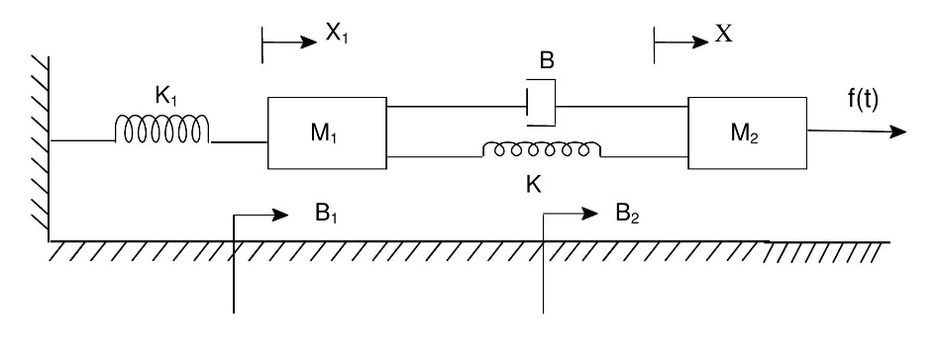 | L3 | CO1 | [8M]
 | OR
8 | Define the signal flow graph and write the mason’s gain formula. | L2 | CO1 | [8M]
9. | Determine the time response of first order system for step input. | L3 | CO2 | [8M]
 | OR
10 | A unity feedback system is characterized by open-loop transfer function G(s) = K/s(s+5). Determine gain K system will have damping ratio of 0.5. For value of K, determine settling time and peak overshoot for a unit-step input. | L5 | CO2 | [8M]
11 | Design root locus of system whose open loop transfer function is  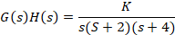  Find the value of k for damping ratio of 0.5 | L4 | CO3 | [8M]
 | OR
12 | Using Routh-Hurwitz criterion, determine stability of closed loop system has following characteristic equation, P(s)=s⁴+3S³+2S²+S+1. Comment on the location of the roots of characteristic equation.  . | L3 | CO3 | [8M]
13 | Define Gain margin, Phase margin and write its general formulas | L2 | CO4 | [8M]
 | OR
14 | Sketch Bode plot, determine Gain margin and phase margin for the transfer function is given,  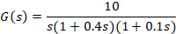 | L5 | CO4 | [8M]
15 | Analyze the calculation of gain crossover frequency and phase crossover frequency with respective to polar plots. | L4 | CO5 | [8M]
 | OR
16 | Sketch the polar plot and determine gain margin and phase margin for the open loop transfer function by G(s) = 1/ s(1+s)(1+2s) | L4 | CO5 | [8M]
17 | Determine the state controllability and observability of the system described by  =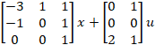;y=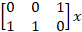 | L5 | CO6 | [8M]
 | OR
18 | Derive the state transition matrix and write its properties. | L4 | CO6 | [8M]

-- 00 -- 00 –

